

School of Computing SRM IST, Kattankulathur –603 203 Course Code: 18CSC302J

Course Name: Computer Networks

|  |  |
| --- | --- |
| **Title** | Home Automation System |
| **Team Members** | Aryan Singh, Prasoon Gautam, Aniket Wakodikar, Nikhil Pal |
| **Register Number** | Aryan Singh(RA2011033010179)  Prasoon Gautam(RA2011033010180)  Aniket Wakodikar (RA2011033010183)  Nikhil Pal(RA2011033010178) |

**TABLE OF CONTENTS**

**S.NO. TITLE PAGE NO.**

1. Abstract 3
2. INTRODUCTION 4
3. OBJECTIVE OF PROJECT 5
4. LITERATURE SURVEY 6
5. SCOPE OF PROJECT 11
6. METHODOLOGY 12
7. HARDWARE 13
8. ARCHITECTURE DIAGRAM 24
9. MODEL EXPLANATION 25
10. FUNCTIONAL BLOCK DIAGRAM 27
11. RESULT 28
12. REFERENCE AND BIBLIOGRAPHY 29

# ABSTRACT

This project presents a design and prototype implementation of new home automation system that uses WiFi technology as a network infrastructure connecting its parts. The proposed system consists of two main components; the first part is the server (web

server), which presents system core that manages, controls, and monitors users’ home.

Users and system administrator can locally (LAN) or remotely (internet) manage and control system code. Second part is hardware interface module, which provides appropriate interface to sensors and actuator of home automation system.

Unlike most of available home automation system in the market the proposed system is scalable that one server can manage many hardware interface modules as long as it exists on WiFi network coverage. System supports a wide range of home automation devices like power management components, and security components.

The proposed system is better from the scalability and flexibility point of view than the commercially available home automation systems.

# INTRODUCTION

The project aims at designing an advanced home automation system using normal web server and Wi-Fi technology. The devices can be switched ON/OFF and sensors can be read using a Personal Computer (PC) through Wi-Fi.

Automation is the most frequently spelled term in the field of electronics.

The hunger for automation brought many revolutions in the existing technologies. These had greater importance than any other technologies due to its user-friendly nature. These can be used as a replacement of the existing switches in home which produces sparks and also results in fire accidents in few situations. Considering the advantages of Wi-Fi an advanced automation system was developed to control the appliances in the house.

Wi-Fi (Short for Wireless Fidelity) is a wireless technology that uses radio frequency to transmit data through the air. Wi-Fi has initial speeds of 1mbps to 2mbps. Wi-Fi transmits data in the frequency band of 2.4 GHz. It implements the concept of frequency division multiplexing technology. Range of Wi-Fi technology is 40-300 feet.

The controlling device for the automation in the project is a Arduino UNO. The data sent from PC over Wi-Fi will be received by Wi-Fi module connected to Arduino UNO. Arduino UNO reads the data and decides the switching action of electrical devices connected to it through Relays.

`

# OBJECTIVE OF PROJECT

The goal of this project is to develop a home automation system that gives the user complete control over all remotely controllable aspects of his or her home.

The automation system will have the ability to be controlled from a central host PC, the Internet, and also remotely accessed via a Pocket PC with a Windows Mobile based application.

The main objective of this system is to control the home appliances and electronic devices with the help of a supervisory system. The supervisory system is designed in such a way that everyone can access it.

Home automation systems are composed of hardware , communication and electronic interface that work to integrate electrical devices with one another.

Another objective of home automation include that it can be regulated with the touch of a button. For any remote location , users can adjust the controls on home entertainment systems , limit the amount of sunlight give to houseplants , or change the temperature in certain rooms . Home automation system is often connected through computer networks so that the user can adjust settings on their personal devices

The System will also sense the Accidental Gas leakage , water level and will notify the user by SMS.

# LITERATURE SURVEY

###### Literature survey:

**Review of Related Literature:**

When people think about home automation, most of them may imagine living in a smart home: One remote controller for every household appliance, cooking the rice automatically, starting air conditioner automatically, heating water for bath automatically and shading the window automatically when night coming. To some extent home automation equals to smart home. They both bring out smart living condition and make our life more convenient and fast.

###### Review of Foreign Studies:

In their paper, Tan, Lee and Soh (2002) proposed the development of an Internet-based system to allow monitoring of important process variables from a distributed control system (DCS). This paper proposes hardware and software design considerations which enable the user to access the process variables on the DCS, remotely and effectively

Potamitis, Georgila, Fakotakis, and Kokkinakis, G. (2003) suggested the use of speech to interact remotely with the home appliances to perform a particular action on behalf of the user. The approach is inclined for people with disability to perform real-life operations at home by directing appliances through speech. Voice separation strategy is selected to take appropriate the rice automatically, starting air conditioner automatically, heating water for bath automatically and shading the window automatically when night coming. To some extent home automation equals to smart home. They both bring out smart living condition and make our life more convenient and fast.

In the year 2006 , S. M. Anamul Haque,S. M. Kamruzzaman and Md. Ashraful Islam proposed a system entitled “ A System for Smart -Home Control of Appliances Based on Time and Speech Interaction” that controls the home appliances using the personal computer. This system is developed by using the Visual Basic 6.0 as programming language and Microsoft voice engine tools for speech recognition purpose. Appliances can be either controlled by timer or by voice command.

Ciubotaru-Petrescu, Chiciudean, Cioarga, and Stanescu (2006) present a design and implementation of SMS based control for monitoring systems. The paper has three modules involving sensing unit for monitoring the complex applications. A processing unit, that is microcontroller and a communication module that uses GPRS modem or cell phone via serial port RS-232. The SMS is used for status reporting such as power failure. Jawarkar, Ahmed, Ladhake, and Thakare (2008) propose remote monitoring through mobile phone involving the use of spoken commands. The spoken commands are generated and sent in the form of text SMS to the control system and then the microcontroller on the basis of SMS takes a decision of a particular task.

Prof. Era Johri Dept. Of Information And Technology K.J.Somaiya College Of Engineering VIDYAVIHAR, MUMBAI “ Remote Controlled Home .

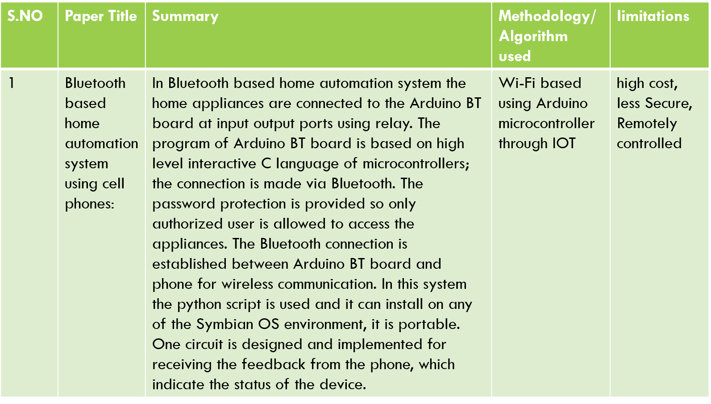

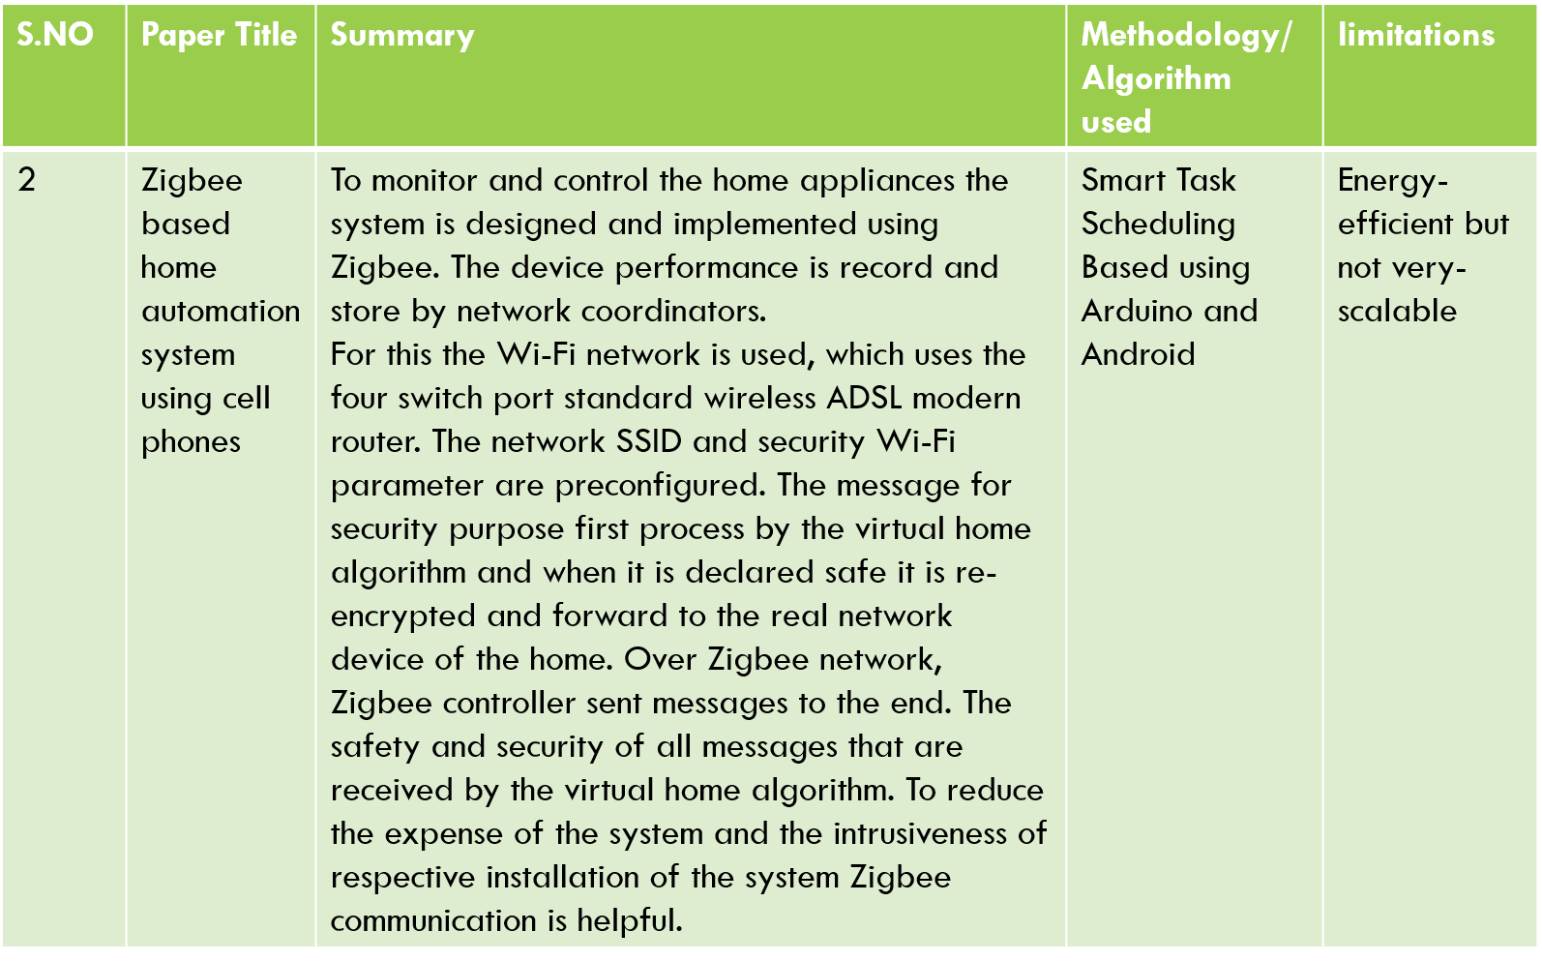

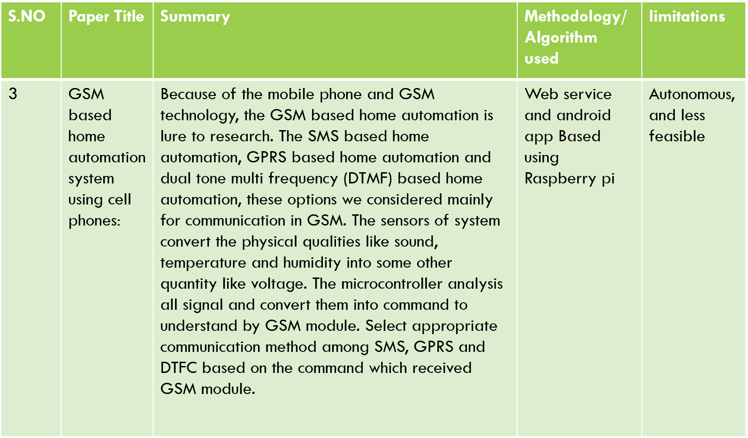

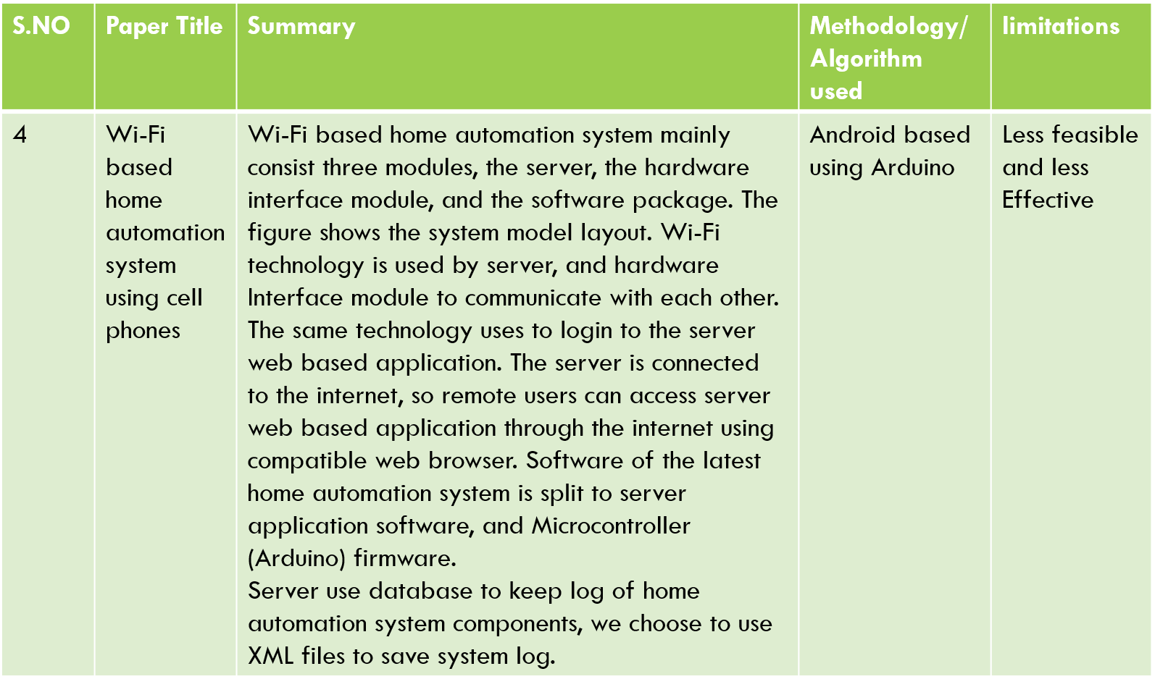

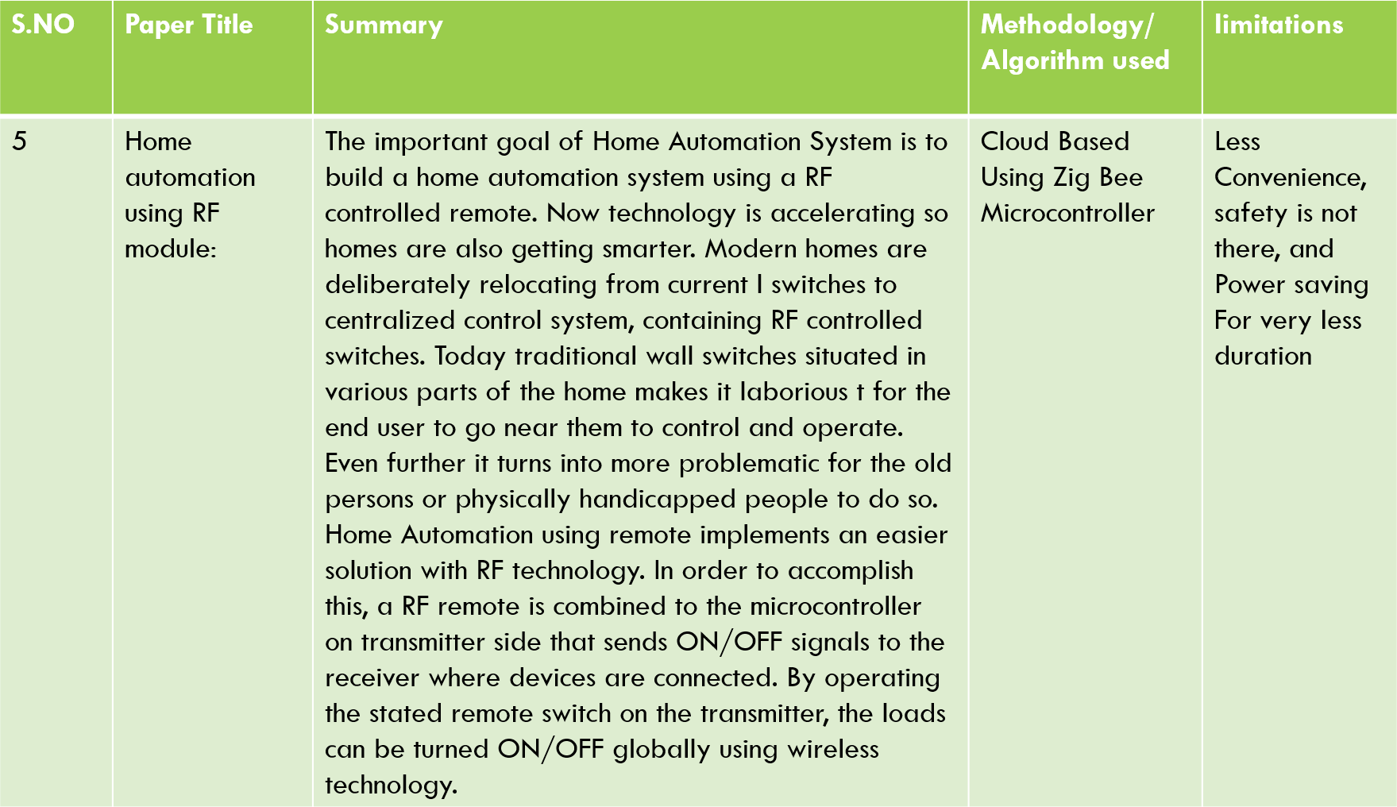

# SCOPE OF PROJECT

Day by day, the field of automation is blooming and these systems are having great impact on human beings. The project which is to be implemented is a home automation using Easy IOT Webserver and WIFI and has very good future development.

With the evolution of Internet of Things (IOT) all these manually controlled electrical and electronic devices can be controlled automatically. In 2011 it was predicted that IOT'S application will focus on mainly on the smart city construction and digital agriculture construction. China Communication Standards Association gives three layer structure of IOT: The first layer is the sensing layer mainly used for collecting information; The second layer is the network layer used for information transmission and processing; The third layer is the application layer used for storage and decision

making . The main concept of IOT is that it can create a virtual connection between a hub or a network and electronic and electrical objects.

In the current system webserver is installed on a windows PC so the home appliances can be controlled using only by using the device on which webserver is installed. This can be further developed installing webserver on cloud .

This virtual connection helps to control, locate, and track down these connected objects. On the basis of device-to-device connectivity concept the development of smart sensor together with communication technologies such as Wi-Fi, Bluetooth etc. and supported by cloud computing technologies, IOT has become reality and it's goal is to make devices more aware, interactive and efficient for a better and safer world

Advantage of installing webserver on the cloud is that home can be controlled by using any device which has WIFI 802.1 and a web browser. By visiting the IP address of the cloud the control actions can be taken.

### METHODOLOGY

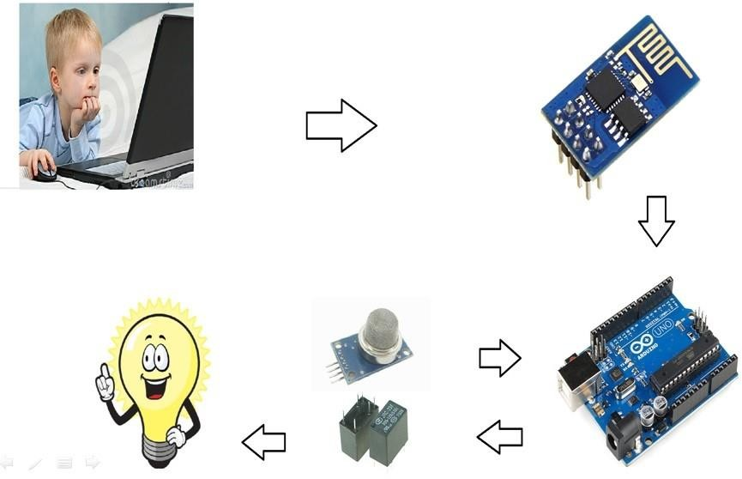

**HARDWARE**

**Arduino:-**

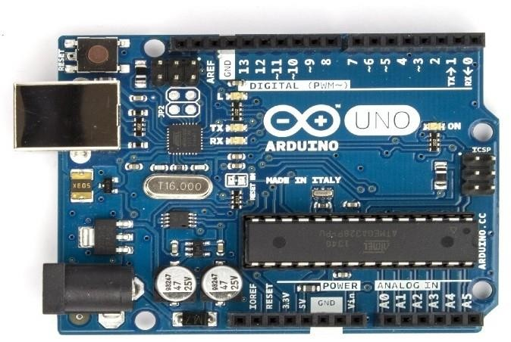

The Arduino Uno is a microcontroller board based on the ATmega328 (datasheet). It has 14 digital input/output pins (of which 6 can be used as PWM outputs), 6 analog inputs, a 16 MHz ceramic resonator, a USB connection, a power jack, an ICSP header, and a reset button. It contains everything needed to support the microcontroller; simply connect it to a computer with a USB cable or power it with a AC-to-DC adapter or battery to get started.The Uno differs from all preceding boards in that it does not use the FTDI USB- to-serial driver chip. Instead, it features the Atmega16U2 (Atmega8U2 up to version R2) programmed as a USB-to-serial converter.

The Uno is a microcontroller board based on the ATmega328P. It has 14 digital input/output pins (of which 6 can be used as PWM outputs), 6 analog inputs, a

16 MHz quartz crystal, a USB connection, a power jack, an ICSP header and a reset button. It contains everything needed to support the microcontroller; simply connect it to a computer with a USB cable or power it with a AC-to-DC

adapter or battery to get started..

"Uno" means one in Italian and was chosen to mark the release of Arduino Software (IDE) 1.0. The Uno board and version 1.0 of Arduino Software (IDE) were the reference versions of Arduino, now evolved to newer releases. The Uno board is the first in a series of USB Arduino boards.

##### Technical specifications:-

Microcontroller ATmega328P Operating Voltage 5V

Input Voltage (recommended) 7-12V Input Voltage (limit) 6-20V

Digital I/O Pins 14 (of which 6 provide PWM output) PWM Digital I/O Pins 6 Analog Input Pins 6

DC Current per I/O Pin 20 mA DC Current for 3.3V Pin 50 mA

Flash Memory 32 KB (ATmega328P) of which 0.5 KB used by bootloader SRAM 2 KB (ATmega328P)

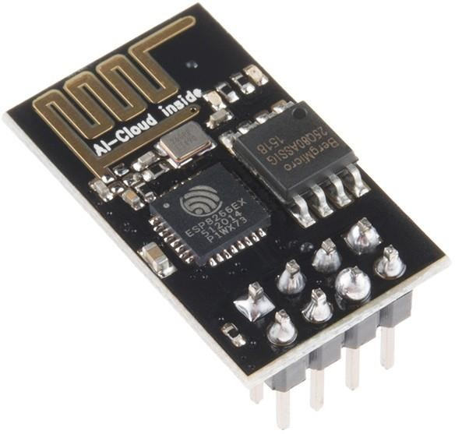

Description: The ESP8266 WiFi Module is a self contained SOC with integrated TCP/IP protocol stack that can give any microcontroller access to your WiFi network. The ESP8266 is capable of either hosting an application or offloading all Wi-Fi networking functions from another application processor. Each ESP8266 module comes pre- programmed with an AT command set firmware, meaning, you can simply hook this up to your Arduino device and get about as much WiFi-ability as a WiFi Shield offers (and that’ s just out of the box)! The ESP8266 module is an extremely cost effective board with a huge, and ever growing, community.

This module has a powerful enough on-board processing and storage capability that allows it to be integrated with the sensors and other application specific devices through its GPIOs with minimal development up-front and minimal loading during runtime. Its high degree of on-chip integration allows for minimal external circuitry, including the front-end module, is designed to occupy minimal PCB area. The ESP8266 supports APSD for VoIP applications and Bluetooth co-existance interfaces, it contains a self- calibrated RF allowing it to work under all operating conditions, and requires no external RF parts.

There is an almost limitless fountain of information available for the ESP8266, all of which has been provided by amazing community support. In the Documents section below you will find many resources to aid you in using

the ESP8266, even instructions on how to transforming this module into an IoT (Internet of Things) solution!

##### Features:

* 802.11 b/g/n
* Wi-Fi Direct (P2P), soft-AP
* Integrated TCP/IP protocol stack
* Integrated TR switch, balun, LNA, power amplifier and matching network
* Integrated PLLs, regulators, DCXO and power management units

• +19.5dBm output power in 802.11b mode

* Power down leakage current of <10uA
* 1MB Flash Memory
* Integrated low power 32-bit CPU could be used as application processor
* SDIO 1.1 / 2.0, SPI, UART
* STBC, 1× 1 MIMO, 2× 1 MIMO
* A-MPDU & A-MSDU aggregation & 0.4ms guard interval
* Wake up and transmit packets in < 2ms
* Standby power consumption of < 1.0mW (DTIM3)

### Specification of ESP 8266:

* Wi-Fi Direct (P2P), soft-AP
* Integrated TCP/IP protocol stack
* Integrated TR switch, balun, LNA, power amplifier and matching network
* Integrated PLLs, regulators, DCXO and power management units
* 19.5dBm output power in 802.11b mode
* Power down leakage current of <10uA
* 1MB Flash Memory
* Integrated low power 32-bit CPU could be used as application processor
* Standby power consumption of < 1.0mW (DTIM3)

**Relayboard:-**

A relay is an electrical device which is generally used to control high voltages using very low voltage as an Input.

This consists of a coil wrapped around a pole and a two small metal flaps(nodes) that are used to close the circuit. One of the node is fixed and other is movable. Whenever an electricity is passed through the coil, it creates a magnetic field and attracts the moving node towards the static node and the circuit gets completed. So, just by applying small voltage to power up the coil we can actually complete the circuit for the high voltage to travel. Also, as the static node is not physically connected to the coil there is very less chance that the Microcontroller powering the coil gets damaged if something goes wrong.

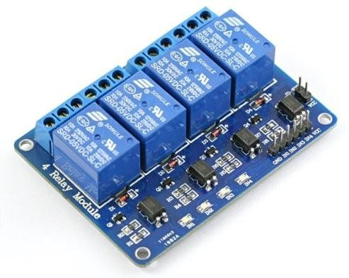

This is Four Channel relay board controlled by computer USB port. The usb relay board is with 4 SPDT relays rated up to 10A each. You may control devices 220V / 120V (up to 4) directly with one such relay unit. It is fully powered by the computer USB port. Suitable for home automation applications, hobby projects, industrial automation. The free software allows to control relays manually, create timers (weekly and calendar) and multivibrators, use date and time for alarms or control from command line. We provide software examples in Labview, .NET, Java, Borland C++, Python

### Features:-

* Datasheet - here
* Power led: Yes
* Relay leds: YesHigh quality
* 4 SPDT Relay channels - selectable by user:
* Current consumption: 400 mA
* Chip: FT245RL
* Size: 77mm x 56mm x 17mm
* Supported by :DRM software
* Supported by(Windows, Linux): Yes
* Android software available (low cost but very useful): Yes

## Advantages:-

* High quality
* Low cost
* No extra power supply
* Software with many functions
* Control electrical devices according weekday/date/time
* Create timers or pulses with our software

## Applications:-

* Home automation
* Robotics
* Alarms
* Timers
* Open doors and windows via PC
* Aquariums applications

##### Additional information:-

This is relay board with 4 SPDT Relays controlled from USB port of your computer. The main purpouse of this USB relay module is to help you building projects regarding robotics and home automation (domotic). You may control differenet electrical devices like home lights, DC motors, pneumatic cylinders, lasers and so on. Each such board requires one USB port. The more USB ports you have the more such relay units you may connect and control. . The relay module outputs are controlled by FT245RL. It has 8 bit data output register (this device use only 4 of them). The usb relay card can not be controlled directly via COM port - you need to download our DRM Software to control the device. The usb relay unit can not work without PC. Only one such device can be supplyed from single USB port. If you want to supply many such devices you need USB HUB with extra power supply.

**USB TO TTL CONVERTER:-**

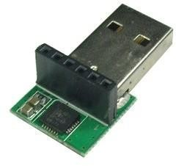

This USB to TTL converter combine the USB-232-1 (USB to Single RS232 Adapter) and TTL-232-1

It can be used to set up APC220 Radio Data Module(SKU:TEL0005) wireless module. It can be used as STC microcontroller program downloader.

##### Specification

Voltage: 5V

Chip: Silicon Laboratories CP210x chip

#### Pin Definition:

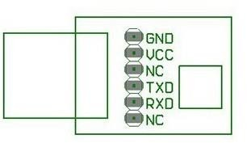

**Esp 8266 firmware:-**

**Required hardware and software:**

You will need a Windows PC for this update

You will need some form of USB to Serial converter that allowsoperation at 3.3V. I used a Focaboard. It allows easy plugging into a breadboard, which then allows me to hookup the pins of the ESP8266 modulevia jumper wires to the corresponding pins on the USB<->Serial board.

The firmware updating software only works on COM ports 1-6. Ifyour USB<->Serial device enumerates to a higher port number than that, you

will have to change it via *Device Manager* in Windows

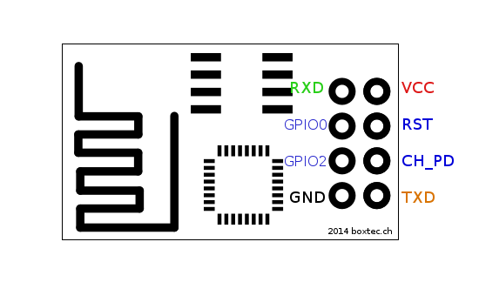

Above is a pin out diagram for the ESP8266 Module

You need to hookup these pins from the ESP8266 to your USB<->Serial board:

* VCC to 3.3V
* GND to ground
* CH_PD to 3.3V
* TXD to RX, RXD to TX *(this may depend on the USB<->Serial board you are using. If it doesn't work, try swapping them around)*
* GPIO0 to ground *(for the duration of firmware upgrading. After all the upgrades have been loaded, it needs to be disconnected)*

You will need to unplug and re-plug the USB cable 4 times during the process,

so make sure you can reach it easily

#### Architecture diagram:

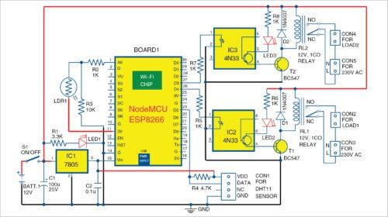

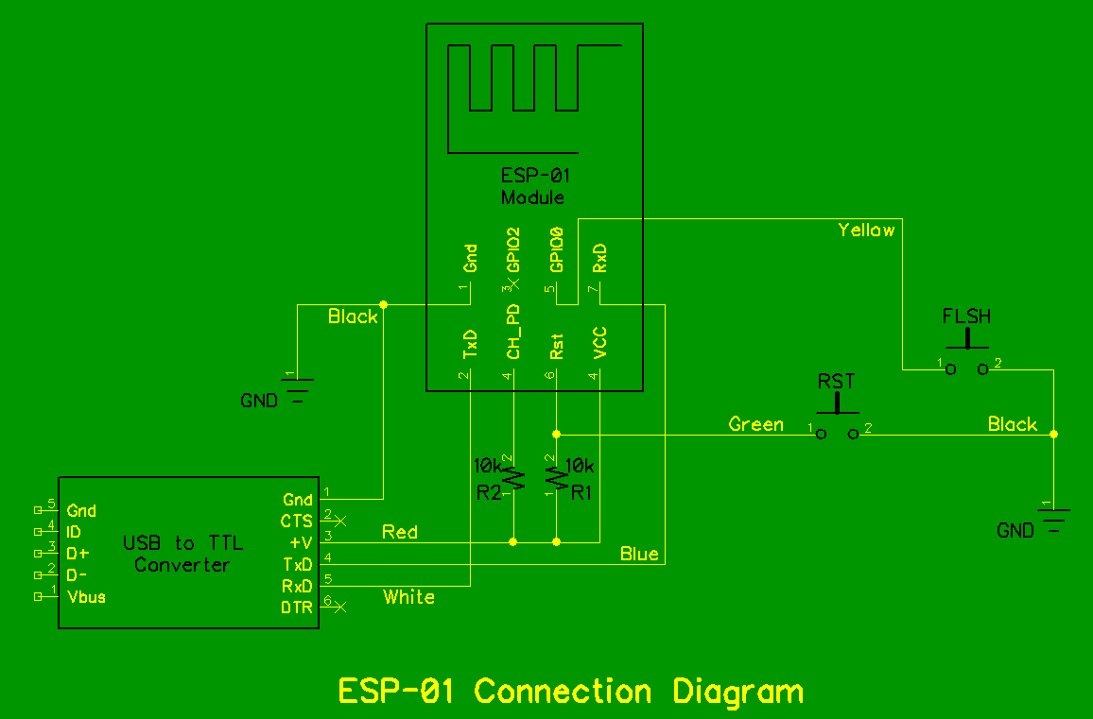

**Model Explanation**

The PHP programming language is used to create a point to-point web socket and a web application. After creation of such a socket, it is connected to the Amazon cloud server with the help of the internet connection. Now as the whole system is now online, it will look for the received messages from the connected IOT devices as shown . Ones the data is received, it will show notification and will refresh the data after certain interval. This refreshed data will be send to the control user interface. The control user interface is everything that the user has to act upon.

The received data in the control user interface is shown in the monitor or on the control screen. Now to change the status of any devices the user needs to obtain the registered id from the Google Cloud Messaging (GCM). To register the user needs to send a request to the GCM.

In response to that the GCM will send the registration id and a unique password shown. The registration id is then send to the subscription API which sends notification and registration id to the GCM. The GCM in turn sends the notification to the client having that registration id. As now the user has the registration id, the user can send command to the connected IOT devices. As the user login, the user can control all the electrical and electronic devices in every section of the house. By entering to each window as shown in fig. The user can change the status of each appliances and can control the security system. This cycle continues until the server or the connected IOT devices is not connected with the internet.

**Model Explanation**

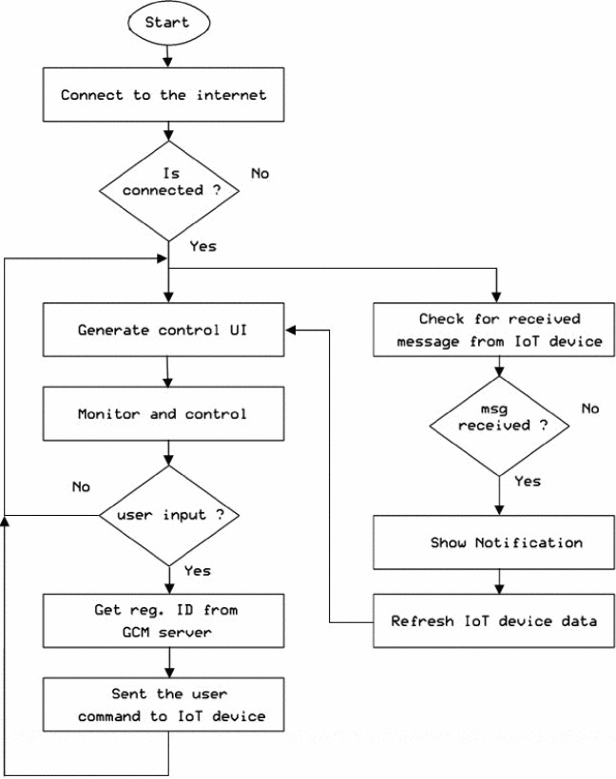

#### FUNCTIONAL BLOCK DIAGRAM

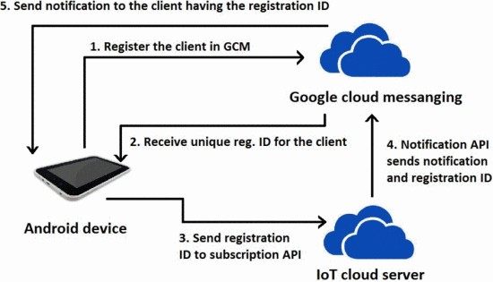

**USING CISCO PACKET TRACER**

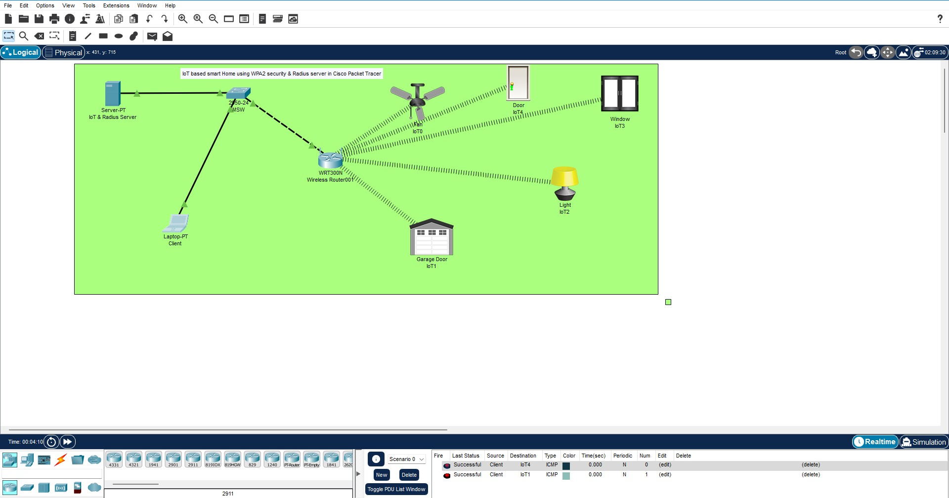

**RESULT**

The IOT system we have developed is tested by installing smart sensor units and setting up a server for few houses. After installing the smart sensor units, the user needs to install the software to his/her laptop or smart android phone. After proper installation of the provided software the user needs to sign-up on the home automation server. Once the user is registered, a unique user id and a password is provided to the users of each house in which the sensor units are installed. After the user id and the unique password are obtained user can login from our android application. When user start the android application first a login page will appear as shown . It was observed that the user can successfully login.

As soon as the user login, a home page will appear in which the user could keep a track of all the electronic and electrical devices which are connected with the server as shown. Our designed model of home automation can also controlled by using any web browser. To operate home automation system user need to go web-page of home automation system then a login page as shown will be appeared. By login in this page the main home automation page as shown will showed. From this page user can control his/her home appliances and change the security settings. This was possible due to the database present with the server which stores all the data received from the server. A threshold value is provided to each sensor connected. If the sensor parameter exceeds the threshold value provided an automatic alarm is triggered.

REFERENCE AND BIBLIOGRAPHY

**References & Bibliography:-**

**Websites:**

* + [http://www.iot-playground.com](http://www.iot-playground.com/)
  + [http://www.instructables.com](http://www.instructables.com/)
  + [http://en.wikipedia.org](http://en.wikipedia.org/)
  + <http://www.journals.elsevier.com/easyiot>

Journals & other books:

* + 1 .Kusuma S M, Assistant Professor, Department of telecommunication, MSRIT, Bangalore, India. “ Home Automation Using Internet of Things.”
  + 2.Niharika Shrotriya, Anjali Kulkarni, Priti Gadhave, International Journal of Science, Engineering and Technology Research (IJSETR), “ SMART HOME USING WI-FI”
  + Anushri Aware, SonaliVaidya,PriyankaAshture, VarshaGaiwal PES’ s Modern College of Engineering, Pune-04, International Journal of Engineering.